On a scale of 1-5 how democratic would you rate the Maduro government, with 1 being not democratic at all and 5 being completely democratic.
Some people say that the democratic rights in the country were not respected by the Maduro government while others say that the Maduro government did respect democratic rights. Which do you agree with?

Some people say that democratic governments are not as effective at fighting crime as authoritarian governments are, while others say that democratic governments are more effective at fighting crime than authoritarian governments. Which opinion do you agree with more?
Some people say that people’s rights must be restricted in democratic countries in Latin America in order for the police to effectively fight crime while others say that people’s rights in a democracy must be respected (protected?) even if that means crime goes up. Which opinion do you agree with?
How in agreement are you with the following statement: Democratic rights must be protected, even if these rights make it harder for the police to fight crime?

Which matters more to you: Living in a country that is democratic or living in a country with low rates of crime?
Assume in the next 12 months the government takes steps to guarantee that all citizens’ rights will be respected and committed to strengthening democracy in the country. If this meant that crime/violence/insecurity would increase would you be in favor of these steps?

Since 2015 the Maduro government has implemented initiatives that take a heavy handed approach to crime. Some examples of this approach include the OLP and the FAES. Were you or any of your friends or family members affected by the OLP and/or FAES raids?

Some people say initiatives like the OLP and the FAES made the country safer, while some say that it made the country less safe. Which position more closely matches your own?
Take a look at the following images of state security officers. Which of these officers do you think is more likely to deter crime?
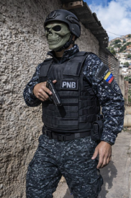

CLAP opinion questions
.

